

MSc Computer Science
Faculty of Arts, Science, and Technology
MSc Computer Science

Level: 7

Module: COM757 Artificial Intelligence

Assignment: 1

Issue Date:
Review Date:

Submission Dates: 9 January 2026
Lecturer: Akeel Afreedi

To be completed by student:  I certify that, other than where collaboration has been explicitly permitted, this work is the result of my individual effort and that all sources for materials have been acknowledged. I also confirm that I have read and understood the codes of practice on plagiarism contained  within the Glyndŵr Academic Regulations and that, by signing this printed form or typing my name on an electronically submitted version, I am agreeing to be dealt with accordingly in any case of suspected unfair practice. I also certify that my attendance for the module has been at least 70% | Name: M.A. Anoj Thilina Perera  Student Number: S25021960  Date Submitted: 2026-01-09  Student Signature: S25021960@mail.glyndwr.ac.uk
Are extenuating circumstances being claimed? NO
If YES, give reference number: --------------------------------------
To be completed by lecturer Comments:
Grade / Mark
(Indicative: may change when moderated)

Venue-Aware AI Assistant (VAAA) for Live Sound Mixing

Table of Contents

1. Introduction 4
2. Problem Context 4
2.1. Domain Description and Specific Issue 4
2.2. Importance & Evidence 5
2.3. Opportunities & Risks of Using AI in the Domain of Live Mixing 5
3. Critical Review of Literature 6
3.1. Survey Process 6
3.2. Comparative analysis of AI approaches 6
3.3. Gaps and opportunities for innovation 7
4. Conceptual AI Solution 7
4.1. Assumptions and Design Goals 7
System Overview 7
4.2. Data Inputs and Sources 8
4.3. Knowledge Representation and Modeling 9
4.4. Logic of Decision Making 9
4.5. Evaluation Plan and Metrics 9
5. Ethical/Societal Reflection 9
5.1. Major Risk 9
5.2. Mitigation 9
6. Conclusion 10
References 10

Introduction

The live music industry depends heavily upon the technical skills and natural ability of sound engineers to produce quality sound in acoustic environments which are both difficult and unpredictable; thus achieving the best possible balance of instruments and vocals is a complex task that requires engineers to make constant, real time decisions regarding levels, frequency response (equalization), spatial placement and dynamic range reduction [1] [2]. However, because of the manual nature of the process of balancing and adjusting the various parameters involved in creating an ideal mix and due to the changing acoustic characteristics of each new venue engineers have historically been required to be highly reactive as opposed to being proactive in their decision making processes when it comes to producing the perfect mix for their audience [3].
Due to the increasing complexity of audio systems, there is a growing need for “smart” or “intelligent” tools that can assist engineers in providing both the technical accuracy of audio engineering and the creative expression they require [2]. In this regard this report will discuss the Venue Aware AI Assistant (VAAA) a proposed tool designed to provide engineers with intelligent, adaptive assistance in automating many common aspects of the mixing process and adapting the mixing to the unique sonic properties of each venue using a combination of multiple point sensors and advanced machine learning algorithms. Therefore the next sections will outline the context of the problem that this research aims to address, provide a critical analysis of how artificial intelligence (AI) is currently being used in the production of audio and describe a conceptual design for the VAAA, including data flow and model logic, and then conclude by exploring the ethics and social impacts of integrating AI into the creative economy [2].

Problem Context

Domain Description and Specific Issue
Live sound engineering refers to the process of using an audio reinforcement system to enhance and balance the music and voices of performing artists for the benefit of the audience. Sound engineers use the mixer, which is the heart of their audio console, to manage all the inputs (e.g., microphones and instruments) and send the output (audio signal) to one or more destinations (e.g., Main Front of House speakers, monitors, or webcast streams) [3].
The issue of interest in the domain of live sound engineering is the variable acoustics of the performance environment. Live sound engineers operate in an uncontrolled environment in contrast to a recording studio, whose acoustics do not change depending on how the room is occupied, what the ambient temperature is, or where the audience members sit. Because of this variable nature of live acoustics, the sound engineer is limited to hearing the audio at one location, the Front of House (FOH), which does not accurately represent the sound experienced throughout the rest of the room. This limitation causes a bottleneck for the sound engineer, who cannot monitor or modify the audio quality for all areas of the room simultaneously.
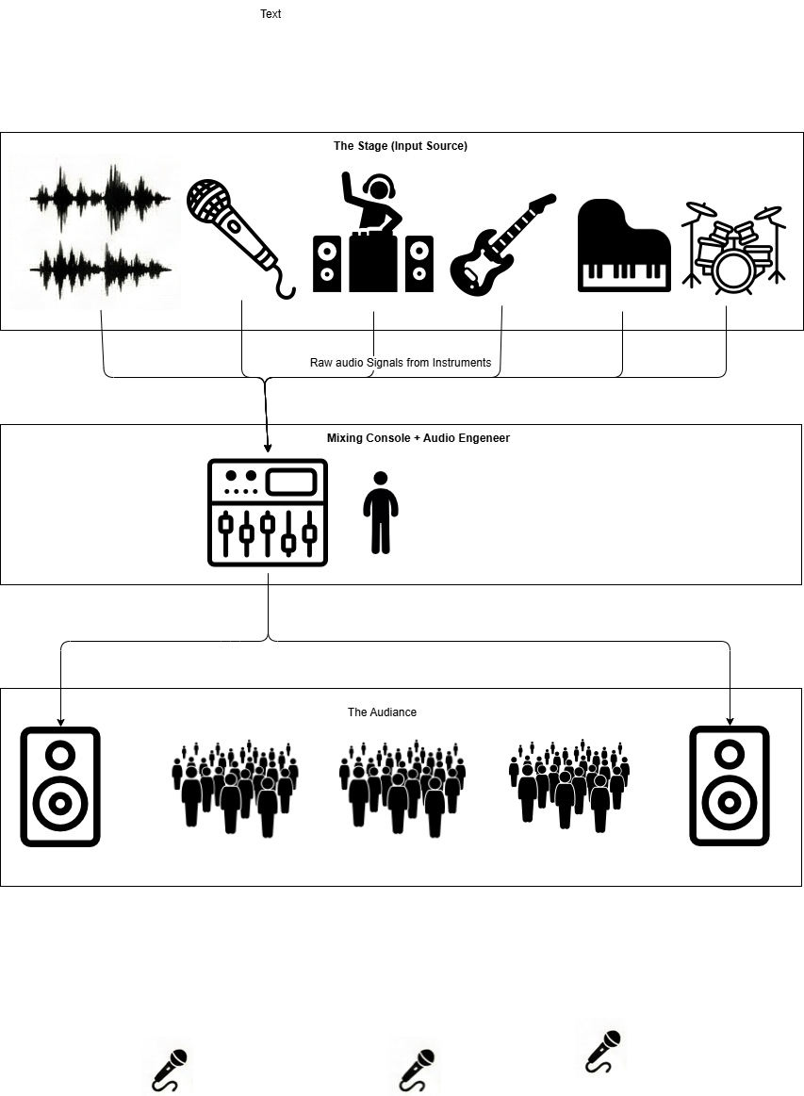
Figure 1: Typical setup of a venue

Importance & Evidence
Sound quality has a direct relationship to the overall audience satisfaction of a live event. The literature cited in Compton [1] shows that sound engineers are subjected to numerous social and cognitive pressures, including fatigue, during the duration of the live event. Additionally, industry data indicates a commonly observed mismatch between the desired volume levels for an event and the actual perceived volumes for the attendees; many live events are too loud due to the decreased hearing sensitivity of the sound engineer after a prolonged exposure to the noise [1]. The adverse consequences of poorly managed sound for both attendees and event producers include potential long-term hearing damage to the former and potential financial losses for the latter due to reputation damage.

Opportunities & Risks of Using AI in the Domain of Live Mixing
There are several benefits that could arise from integrating AI into live mixing:
- Adaptive Changes: AI could take advantage of sensor data collected from various locations in the venue to make adjustments to the audio mix much quicker than a human.
- Consistency: AI could ensure that an artist achieves the same “sound signature” regardless of the physical constraints of the venue.
- Assistance: AI could help reduce the engineer’s workload by automatically managing mundane tasks such as suppressing feedback and adjusting instrument and vocalist levels.
However, there are also several risks associated with the integration of AI into live mixing:
- Homogeneous Aesthetics: There is a risk that the AI produces a “correct” yet uninteresting audio mix that lacks the nuance and creativity that a human would bring to the project.
- Systemic Unreliability: There is the risk that AI system latency, in a situation where there is no undo button.

Critical Review of Literature

Survey Process
The research that pertains to AI-assisted audio mixing can include, but are not limited to, the fields of signal processing, machine learning and human-computer interaction. The review has been framed in line with the needs of a real-time live performance, by filtering the literature through the use of three lenses.

Comparative analysis of AI approaches
Knowledge-driven automation: rule-based and fuzzy systems
Earlier, automated approaches modeled engineering practice by using explicit logical decisions (e.g., "when harshness increases, decrease 2–4 kHz") and were often implemented with fuzzy systems to mirror how engineers use ambiguous terms ("too bright," "muddy") in reasoning [4] . Rule based systems allow for interpretation of their actions so that actions can be traced and audited; and they can also be computationally very efficient when operating under real-time constraints. However, most of the rule based systems rely on relatively stable mappings from acoustic symptom to action. Live sound systems are however highly nonlinear due to changes in audience absorption, microphone spill, and venue reflections which are always changing, therefore static or lightly tuned rule sets can lead to brittle or overly correct responses [1] [3]. This indicates a major drawback for rule-based systems — they fail to generalize well across different venues and styles, unless extensively manually adjusted, thus defeating the goal of scaling up rule based systems [4] [2].
Data-driven perception: deep learning for enhancement and separation
The trend has been toward using deep neural networks (such as U-Net models and other CNN-related models), for audio enhancements, as well as for source separation, and are now commonly viewed as time-frequency learning problems [5] [6] [7]. However, they do offer significant advantages over the older knowledge-based methods of determining complex spectral relationships between overlapping sources [8] [7] which is a critical factor in determining what instruments are present in a mix as well as detecting bad resonance within a mix. While there may be a trade-off for being highly accurate (i.e. operational): High performing models require either a buffer or offline processing, whereas live mixing is subject to very low latency constraints. Therefore, a combination of extracting features (for example through a spectrogram transformation), running an inference on those extracted features and then smoothing those results creates delays that would be unacceptable in the context of real-time performance [5] [6] [2]. In other words, while deep models may offer superior perception, they cannot meet the "real-time" requirement unless their accuracy or robustness is severely compromised by compression, optimization, or offloading [2].
Human-centred AI: assistant tools rather than replacement
Another strand of research suggests that successful AI in music production should serve to assist humans and preserve their intentions as well as the agency involved in creating music, thus allowing them to remain engaged in the process [2] [9]. Designing systems for humans, for example through use of intelligent default values or suggestions based on contextual information, supports the workflow of professionals since engineers do not simply seek to achieve technical "correctness"; they are seeking an aesthetic goal which varies by artist, genre, and expectations of the audience [9] [2]. This area of research indicates an important assumption inherent in a number of automated paper; that there is one single "best" objective for mixing. As discussed in [1] [2], there is no single objective for "good sound", but rather multiple competing objectives (e.g., clarity, loudness, aesthetic quality, safety) whose weightings can vary over time. If the system ignores the human's creative role it will result in a series of "acceptable" mixes that are aesthetically uninteresting and/or culturally uniformized; a problem that may be exacerbated when models are trained using limited data sets [2].

Gaps and opportunities for innovation
Two significant gaps exist in current research. One is that most studies assume a static environment; they do not account for the fact that the physical environment can affect how people perceive and respond to sound at events [1] [3] . The second gap is that most machine learning (ML) solutions have been tested with simulated data in a controlled environment and not in a real event venue where audio systems suffer from the same errors and noise as human hearing [2]. This provides an opportunity for solutions that incorporate: (i) distributed sensors to measure sound levels in the venue, (ii) low latency perception to rapidly identify problems, and (iii) safe, explainable decision making to assist audio engineers and provide an enhanced experience for the audience, rather than full autonomous operation [2] [9].

Conceptual AI Solution

Assumptions and Design Goals
VAAA will maintain a balanced, clear mix throughout the venue with a maximum latency of less than 10 milliseconds. The development of the VAAA will also depend upon the availability of a digital mixer with an accessible API and a reliable wireless network for the distributed microphones.

System Overview
The VAAA operates as a closed-loop system connected to the venue’s digital mixer.
- Input Source: Raw audio signals from instruments.
- Sensing Layer: Distributed RT mics + Direct Mixer Feed.
- Analysis Engine: Instruments Identification + Acoustic Profiling.
- Control Agent: Optimization of Parameters (Gain/EQ/Comp).
- Output: OSC commands to Mixer + Engineer Dashboard.

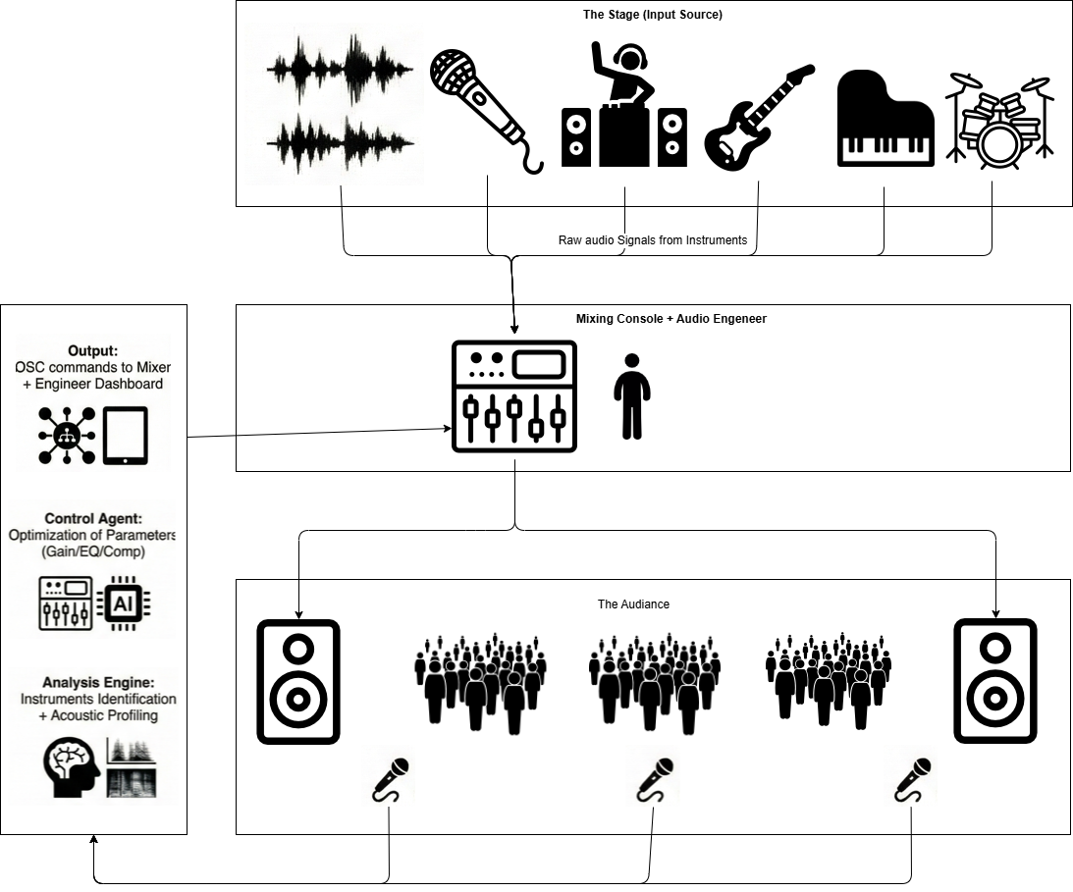
Figure 2: VAAA System Overview

Data Inputs and Sources
The VAAA will utilize multiple forms of input data:
- Unstructured Audio: RT multi-point mics will capture the "room sound" (reverberation, reflections, audience noise) while the mixer will send clean "dry" signals for each channel.
- Structured Metadata: The real-time state of the mixer (fader levels, EQ curves) via the Open Sound Control (OSC) API.
- Preprocessing: The raw audio will be converted into Mel-spectrograms so that the CNN can extract features and see the frequency balance of the room [6].

Knowledge Representation and Modeling
The VAAA will utilize a Hybrid AI Architecture:
Perception Layer (CNN): A pre-trained CNN will identify instruments and detect acoustic anomalies (e.g., feedback frequencies).
Reasoning Layer (Reinforcement Learning): A reinforcement learning (RL) agent will be trained to optimize the "mix clarity" and "tonal balance" of the output. The state will include the current mixer settings, and the action will be small adjustments to those settings.

Logic of Decision Making
The decision making logic will follow a HITL (Human-in-the-Loop) logic. The RL agent will calculate the best mixer settings; however, those settings will not be applied directly to the main output unless the "auto-pilot" mode is turned on. Instead, the system will generate "mixing suggestions" visible on an iPad interface. If the engineer accepts one of the suggested options, the system will send an OSC command to the mixer (e.g., /ch/01/eq/f 250 -3.0).

Evaluation Plan and Metrics
Evaluation will be based on three metrics:
- Acoustic Accuracy: Will be measured by comparing the frequency response at the front of house position with remote audience areas using the RT mics.
- Efficiency: Will be measured by determining the percentage of manual adjustments made by the engineer.
- Explainability: The system must explain why it took a certain action (e.g., "cutting 400 Hz to reduce room resonance").

Ethical/Societal Reflection

Major Risk
The major risk associated with this project is the potential for algorithms to generate aesthetic biases in how the VAAA sounds. If the VAAA is primarily based on data collected from western pop artists, it has the potential to "fix" the distinct tone and timbre of traditional eastern music styles, creating cultural homogenization. The other significant risk is the potential for "deskilling," where future engineers rely too heavily on the VAAA when an issue arises in their mixing process, potentially causing them to lose the ability to manually mix when needed.

Mitigation
There are several steps that can be taken to address the two major risks identified above. To ensure that the VAAA respects cultural mixing traditions, there needs to be an option to customize "Genre Profiles." All audio will be processed locally at the venue's server using Real-Time (RT) mics. Therefore, no customer conversations will ever be stored or sent to the cloud for data storage purposes.

Conclusion
The Venue Aware AI Assistant (VAAA) represents a move from reactive to adaptive live sound engineering. With the integration of Distributed Acoustic Sensing (DAS) and Real-Time Mixer Control, the VAAA resolves the fundamental problem of venue-specific instability. Although AI will never be able to provide a human engineer with the same level of creative intuition, the VAAA provides a valuable co-pilot in providing technical excellence and ensuring audience safety in the most difficult acoustic environments.

References

[1] | S. Compton, "Live Sound Pressure That Is Not Measured In Decibels: An investigation into live sound culture and the interpersonal pressures that influence audio engineer choice," International Journal of Applied Positive Psychology, vol. 9, pp. 71-100, 2024.
[2] | C. Steinmetz, C. Uhle, F. Everardo, C. Mitcheltree, J. K. McElveen, J.-M. Jot and G. Wichern, "Audio Signal Processing in the Artificial Intelligence Era: Challenges and Directions," Journal of the Audio Engineering Society, vol. 73, no. 7/8, pp. 406-428, August 2025.
[3] | M. Terrell and M. Sandler, "An Offline, Automatic Mixing Method for Live Music, Incorporating Multiple Sources, Loudspeakers, and Room Effects," Computer Music Journal, vol. 36, no. 2, pp. 37-54, 2012.
[4] | L. F. Fermin, "AI Driven Multitrack Audio Mixing Using Fuzzy Logic Tools," University of Texas at San Antonio, San Antonio, 2020.
[5] | D. Koszewski, "Automatic music signal mixing system based on one-dimensional Wave-U-Net autoencoders," EURASIP Journal on Audio, Speech, and Music Processing, vol. 2023, no. 1, 2023.
[6] | S. Gul and M. S. Khan, "A Survey of Audio Enhancement Algorithms for Music, Speech, and Environmental Sounds by Image U-Net," IEEE Access, vol. 11, pp. 140298-140324, 2023.
[7] | L. Moysis, "Music Deep Learning: Deep Learning Methods for Music Signal Processing—A Review of the State-of-the-Art," IEEE Access, vol. 11, p. 10043650, 2023.
[8] | R. Zaheer, "A Survey on Artificial Intelligence-Based Acoustic Source Identification," IEEE Access, vol. 11, pp. 53969-53992, 2023.
[9] | A. Tsiros and A. Palladini, "Towards a Human-Centric Design Framework for AI Assisted Music Production," in International Conference on New Interfaces for Musical Expression (NIME), 2020.
[10] | W. Ma and Z. Zheng, "Applications of Artificial Intelligence in Music: A Review," International Journal of Creative Computing, vol. 1, no. 1, pp. 1-20, 2025.
[11] | C. Fernandez, "Virtual Acoustic Environment Rehearsal and Performance in an Unknown Venue," Virtual Worlds, vol. 4, no. 3, p. 35, 2025.

